AGE AND GENDER PREDICTION IN FACE RECOGNITION SYSTEMS
BACHELOR OF TECHNOLOGY
IN
ELECTRONICS AND COMMUNICATION ENGINEERING
A MAJOR PROJECT REPORT SUBMITTED BY:
JAGRASPALLI AFREEN TAJ 21011A0418
RAVULA SAI PREETHAM 21011A0445
MOHAMMED FAIZ UR RAHMAN 21011A0460

Under the esteemed guidance of DR. P CHANDRASEKHAR REDDY


Department Of Electronics and Communication Engineering Jawaharlal Nehru Technological University Hyderabad, University College of
Engineering, Science & Technology Hyderabad
Autonomous
(Kukatpally-Hyderabad-500085) 2024 – 2025

Department of Electronics and Communication Engineering
Jawaharlal Nehru Technological University Hyderabad Kukatpally, Hyderabad – 500085

CERTIFICATE BY THE SUPERVISOR

This is to certify that the project entitled
“AGE AND GENDER PREDICTION IN FACE RECOGNITION SYSTEMS”
being submitted by

JAGRASPALLI AFREEN TAJ 21011A0418
RAVULA SAI PREETHAM 21011A0445
MOHAMMED FAIZ UR RAHMAN 21011A0460

In partial fulfilment of the requirements for the award of degree in Bachelors of Technology in Electronics and Communication Engineering at the Jawaharlal Nehru Technological University during the academic year 2024-25 is a Bonafide work carried out under my guidance and supervision. The results embodied in this major project report have not been submitted to any other University or institute for the award of any degree or diploma.
SUPERVISOR:
Dr. P Chandrasekhar Reddy
Senior Professor
Electronics & Communication Engineering
JNTUH University College of Engineering, Science & Technology Hyderabad.

Department of Electronics and Communication Engineering
Jawaharlal Nehru Technological University Hyderabad Kukatpally, Hyderabad – 500085

CERTIFICATE BY THE HEAD OF THE DEPARTMENT
This is to certify that the project report entitled
“AGE AND GENDER PREDICTION IN FACE RECOGNITION SYSTEMS”
Submitted by

JAGRASPALLI AFREEN TAJ 21011A0418
RAVULA SAI PREETHAM 21011A0445
MOHAMMED FAIZ UR RAHMAN 21011A0460
In partial fulfilment of the requirements for the award of degree in Bachelor of Technology in Electronics and Communication Engineering at the Jawaharlal Nehru Technological University during the academic year 2024-25 is a Bonafide work carried out by them.

HEAD OF THE DEPARTMENT:

Dr. A Rajani
Professor & Head, Director UIIC, JNTUH
Electronics & Communication Engineering
JNTUH University College of Engineering, Science & Technology Hyderabad

Department of Electronics and Communication Engineering
Jawaharlal Nehru Technological University Hyderabad Kukatpally, Hyderabad – 500085

DECLARATION OF THE CANDIDATES
We hereby declare that the major project report titled “AGE AND GENDER PREDICTION IN FACE RECOGNITION SYSTEMS” is a Bonafide record
work done and submitted under the esteemed guidance of Dr. P Chandrasekhar Reddy, Senior Professor ECE, JNTUHUCESTH, in partial fulfilment of the requirements for Major project in Electronics and Communication Engineering at the Jawaharlal Nehru Technological University during the academic year 2024-25 is a Bonafide work carried out by us and the results kept in the major project have not been reproduced. The results have not been submitted in any other institute or university for the award of degree or diploma.

JAGRASPALLI AFREEN TAJ 21011A0418
RAVULA SAI PREETHAM 21011A0445
MOHAMMED FAIZ UR RAHMAN 21011A0460

ACKNOWLEDGEMENT

This project titled “AGE AND GENDER PREDICTION IN FACE RECOGNITION SYSTEMS” was carried out by us. We are grateful to Prof. Dr. P Chandrasekhar Reddy Sir, Senior Professor of Electronics and Communication Engineering, JNTU, Hyderabad University College of Engineering, Science & Technology Hyderabad, for their guidance while pursuing this project.
We take this precious opportunity to acknowledge our internal project guide Prof. Dr. P Chandrasekhar Reddy Sir, Senior Professor of Electronics and Communication Engineering, JNTUH University College of Engineering, Science & Technology Hyderabad for his timely advice, effective guidance and encouragement throughout the completion of our major-project work. We also owe a deep respect of gratitude to our parents and friends for their cheerful encouragement and valuable suggestions, without whom this work would not have been completed in this stipulated time.
We would like to articulate our heartfelt gratitude to the authorities of JNTU for their help throughout our project work. A few lines of acknowledgement do not fully express our gratitude and appreciation for all those who guided and supported us throughout this project. Last but not in the least, we acknowledge the help received from many journals and websites. Finally, we thank one and all who helped us directly or indirectly throughout our project work.

JAGRASPALLI AFREEN TAJ 21011A0418
RAVULA SAI PREETHAM 21011A0445
MOHAMMED FAIZ UR RAHMAN 21011A0460

Table of Contents

ABSTRACT 8
1. INTRODUCTION 9
1.1. PURPOSE 9
1.2. EXISTING SYSTEM 9
1.3. PROPOSED SYSTEM 10
1.4. PROBLEM DESCRIPTION 10
1.5. SOLUTION 10
2. REQUIREMENTS 12
2.1. OVERVIEW 12
2.2. HARDWARE REQUIREMENTS 12
2.3. SOFTWARE REQUIREMENTS 13
3. IMPLEMENTATION 14
3.1. SYSTEM ARCHITECHTURE 14
3.2. MODEL CONFIGURATION 18
3.3. SOFTWARE INTEGRATION 22
4. WORKING 27
FLOWCHART 31
5. TESTING AND RESULT 33
6. CONCLUSION AND FUTURE SCOPE 38
7. REFERENCES 41
8. BIBILOGRAPHY 42

TABLE OF FIGURES

Figure 1:Block diagram of CNN model 16
Figure 2: Convolutional NN model 18
Figure 3: Pre trained caffe model CNN 19
Figure 4: code part 1 22
Figure 5: code part 2 22
Figure 6: code part 3 23
Figure 7:code part 4 23
Figure 8: code part 5 24
Figure 9: code part 6 24
Figure 10: code part 7 24
Figure 11: code part 8 25
Figure 12: code part 9 25
Figure 13: code part 10 26
Figure 14: code part 11 26
Figure 15:code part 12 26
Figure 16: code part 13 27
Figure 17: flowchart of implementation 31
Figure 18: test1 36
Figure 19: terminal result 1 36
Figure 20: test 2 37
Figure 21: terminal result 2 37

ABSTRACT

The ability to predict age and gender from facial images has emerged as a key aspect in a wide range of applications, such as human-computer interaction, security systems, healthcare, and targeted marketing. The human face carries rich biometric information, and by analyzing facial features, it is possible to gain valuable insights into an individual’s demographic profile. These predictions have the potential to significantly enhance user experience in personalized services, improve security systems, assist in demographic analysis, and enable more accurate consumer targeting in retail.
This project presents a deep learning-based approach for real-time age and gender classification from facial images. The proposed system follows a multi-step framework that begins with face detection using established algorithms. We employ the Haar Cascade algorithm for efficient and reliable face detection, followed by the extraction of facial features from the detected faces. These features are then passed through a Convolutional Neural Network (CNN) model, which is specifically trained to classify both age and gender. The CNN architecture is designed to handle complex facial features and predict the most accurate age group and gender for the given input.
For age prediction, the system categorizes age into broad ranges, such as children, teenagers, adults, and seniors, providing a more generalized estimation that accounts for variations in lighting, makeup, and facial expressions. Similarly, the gender classification is limited to two categories: male and female. While these predictions are based on visible facial features, the system’s accuracy is optimized by considering different age ranges and overcoming potential biases introduced by environmental factors or image quality.
The implementation of this system leverages popular Python libraries and frameworks to handle image processing, model training, and data manipulation efficiently. OpenCV is employed for real-time face detection and image pre-processing, enabling the system to work with live video feeds or static images. Libraries such as NumPy, Pandas, and SciPy are used for data handling, statistical analysis, and optimization of the deep learning model. Keras, a high-level neural network API, is utilized to build, train, and fine-tune the CNN model, ensuring high accuracy and robustness.
The system is designed to process large datasets efficiently and is capable of real-time analysis, making it suitable for real-world applications where speed and accuracy are critical. The proposed solution addresses common challenges in face recognition, such as varying lighting conditions, diverse facial expressions, and the presence of makeup or accessories, which often hinder the accuracy of age and gender predictions from a single image. By employing multiple age categories and leveraging advanced deep learning techniques, the system achieves significant improvements in prediction accuracy.
This project showcases the power of deep learning-based facial recognition systems in demographic prediction. By utilizing cutting-edge image processing techniques and robust neural network models, the system provides an accurate, scalable, and efficient solution for age and gender detection. The proposed approach has promising applications in various domains, including social media, where it can enhance user interactions, security, where it can assist in demographic profiling, and retail, where it can enable targeted marketing strategies based on age and gender predictions.

INTRODUCTION
The ability to predict age and gender from facial images has become an integral component in several modern applications, ranging from personalized services and targeted marketing to enhancing security and improving human-computer interactions. The human face contains unique biometric features that can be analyzed to infer demographic characteristics, which has paved the way for age and gender classification systems.
In this project, we explore the use of deep learning to predict both age and gender from facial images, applying cutting-edge techniques in image processing and neural networks to achieve accurate, real-time predictions. The proposed solution incorporates face detection, feature extraction, and a Convolutional Neural Network (CNN) model, trained specifically for classifying age and gender.

PURPOSE
The purpose of this project is to develop a robust system that can accurately predict a person's age and gender from a given facial image. These predictions are essential in a variety of fields, such as:
- Human-Computer Interaction (HCI): Enhancing the user experience by personalizing services based on demographic data.
- Security Systems: Assisting in demographic profiling for security surveillance.
- Retail and Marketing: Enabling targeted advertisements and personalized shopping experiences.
The system utilizes state-of-the-art deep learning models to process facial images, making predictions based on the visible characteristics of the face. It focuses on handling diverse image conditions like varying lighting, facial expressions, and makeup, which often affect the accuracy of these predictions.

EXISTING SYSTEM
Current facial recognition systems primarily focus on detecting faces for identity verification. However, the specific tasks of age and gender prediction from facial images have gained attention recently due to advancements in deep learning. Existing systems often rely on traditional methods like Haar cascades for face detection and handcrafted features, which may not generalize well to new or diverse datasets.
Moreover, many of these systems focus on either age or gender classification separately, failing to integrate both aspects efficiently. Also, their performance in real-time applications remains limited due to computational demands and lower prediction accuracy under challenging conditions.

PROPOSED SYSTEM
This project proposes a unified system for both age and gender classification from facial images using deep learning techniques. The system integrates:
- Face Detection: Using the Haar Cascade classifier or more advanced methods like Single Shot Multibox Detector (SSD) for detecting faces.
- Feature Extraction: A CNN model to extract features from detected faces.
- Age and Gender Classification: A multi-output CNN model that predicts both the age group and gender based on the extracted features.
By combining these processes into a single pipeline, the system can efficiently predict both characteristics simultaneously, achieving a high degree of accuracy even under challenging conditions like low lighting or occlusions.

PROBLEM DESCRIPTION
Predicting age and gender from facial images poses several significant challenges that need to be addressed to achieve accurate and reliable results. One major obstacle is the variability in lighting conditions. Images captured under different lighting, whether it be bright, dim, or uneven, can introduce shadows or highlights that obscure facial features, making it difficult for models to accurately predict demographic information. Furthermore, facial expressions and makeup can alter the natural appearance of an individual, potentially leading to incorrect classifications. For instance, makeup can significantly change the appearance of a person's features, while varying facial expressions might make age predictions difficult, as the face may not appear as it would under a neutral expression.
Another challenge lies in the diversity of age and gender across various populations. Many existing systems fail to accurately classify individuals from underrepresented groups, especially when dealing with subtle age differences or gender nuances. Additionally, some age ranges may overlap in features, complicating the task for models trained on limited datasets. Lastly, real-time processing remains a significant hurdle. Achieving accurate predictions quickly without sacrificing performance or requiring high-end computational resources is crucial for practical deployment. All these factors make it challenging to create a robust system capable of providing precise predictions across various conditions.

SOLUTION
To tackle the challenges identified above, the proposed system employs a deep learning-based approach designed to maximize prediction accuracy while addressing real-world complexities. Data augmentation is used extensively during training to simulate different environmental conditions and facial variations. By applying techniques such as random rotations, translations, and zooming, the model becomes more robust and better at generalizing to new data. This approach ensures that the model is capable of handling images captured in varying lighting or with diverse facial expressions.
The core of the solution is a Convolutional Neural Network (CNN), which excels at extracting hierarchical features from facial images. This model is capable of learning the subtle differences between faces that indicate age or gender, even in the presence of makeup, expressions, or other challenges. To make the system more efficient, multi-task learning is utilized, where a single model is trained to predict both age and gender. This reduces computational complexity while improving the model’s overall performance by sharing learned features between the two tasks.
Additionally, the system is designed with an emphasis on real-time processing, ensuring that predictions are made quickly and efficiently. The CNN model is optimized for speed and accuracy, allowing the system to be deployed in various practical applications, including real-time video feeds or live camera systems. By combining deep learning, real-time image processing, and data augmentation, the solution addresses the issues of accuracy, scalability, and efficiency, making it suitable for applications in human-computer interaction, security, retail, and more.

REQUIREMENTS

OVERVIEW
This chapter outlines the requirements essential for the successful development and deployment of the Age and Gender Prediction System based on facial images. It describes the resources and tools needed for both the software and hardware components, which are integral to the system's operation.
The system relies on advanced image processing and machine learning techniques to detect and predict the age and gender of individuals. For this, the system needs specific software tools to handle tasks such as face detection, image pre-processing, and neural network training. Similarly, it also requires adequate hardware infrastructure to support real-time facial analysis, model training, and high-performance computations.
This section will provide a detailed overview of the software libraries and tools required for image processing, model execution, and data manipulation. It will also specify the hardware components, including cameras, processing units, and storage systems, needed to ensure smooth operation and accurate predictions.
The combination of the right software and hardware resources is crucial to ensuring that the system functions efficiently, providing real-time predictions with minimal latency.

HARDWARE REQUIREMENTS
For the system to operate efficiently and meet real-time performance criteria, specific hardware components are required. These include the following:
- Computer/Server with Sufficient Processing Power: The system requires a computer with a multi-core CPU and GPU (Graphics Processing Unit) for performing deep learning operations and real-time image processing. A high-performance GPU (such as an NVIDIA GPU) is recommended for accelerating the deep learning model inference, significantly improving the speed of the age and gender prediction tasks.
- Camera: A high-resolution camera is essential for capturing clear facial images. The quality of the input image directly impacts the accuracy of the face detection and subsequent age and gender predictions. A webcam or external USB camera with at least 720p resolution is typically used for real-time applications, but higher resolution cameras are recommended for greater precision in predictions.
- Storage Device: Sufficient disk space is required to store pre-trained models, image datasets, and any real-time video or image data captured during system operation. At least 10GB of free storage should be available for handling model files and processing images.
- Operating System: The system is compatible with both Windows and Linux operating systems. It is recommended to use a 64-bit OS for optimal performance, especially for handling large datasets and deep learning computations.

SOFTWARE REQUIREMENTS
The software requirements for the proposed system include a set of libraries and frameworks that are essential for tasks such as image processing, model training, and real-time facial analysis. The system primarily relies on the following software components:
- Python Programming Language: Python is the core programming language used for developing the system due to its extensive support for image processing, machine learning, and deep learning. Python is both easy to use and efficient for handling tasks related to computer vision and neural networks.
- OpenCV (Open Source Computer Vision Library): OpenCV is a powerful library for computer vision tasks. It provides functions for face detection, image manipulation, and pre-processing. The system uses OpenCV’s dnn module to load and run pre-trained models for face, age, and gender detection.
- Keras/TensorFlow: Keras, a high-level neural network API, is used to build, train, and fine-tune the deep learning models (specifically CNNs). TensorFlow serves as the backend for Keras and handles the computational operations required for deep learning.
- NumPy: NumPy is used for numerical computing in Python, particularly for matrix operations, which are a key part of deep learning model operations and image processing.
- Pandas and Matplotlib (Optional): These libraries can be used for handling datasets, performing data analysis, and visualizing the results of the predictions, although they are not strictly necessary for the core functionality of the system.
These software components enable the system to detect faces in real-time, extract facial features, and process them through a neural network model for accurate predictions of age and gender.

IMPLEMENTATION

SYSTEM ARCHITECHTURE

System integration refers to the coherent combination of all individual subsystems—both hardware and software—into a complete and functional application. In the context of the Age and Gender Detection System, it involves bringing together several deep learning models, image processing techniques, hardware resources (CPU/GPU), and user interface elements to create an end-to-end solution that processes an input image and accurately outputs the detected age and gender of individuals present.

  - Functional Integration of Modules

The system is composed of three major logical components:
- Face Detection Module
- Age Prediction Module
- Gender Prediction Module
Each module is based on a pre-trained deep neural network and serves a specific purpose. The integration ensures that the output of one module (e.g., detected face coordinates) serves as the input for the next (e.g., face cropping and age/gender classification). The system is architected to allow seamless information flow between these components.
This modular integration is beneficial because:
- It allows for independent testing of each component.
- Modules can be replaced or upgraded (e.g., replacing a face detector with a newer model).
- It supports reusability in other computer vision applications.

  - Data Flow and Inter-Module Communication

The integration is not only functional but also data-oriented. The system ensures:
- Images are correctly resized, normalized, and transformed into blobs (as required by the DNNs).
- Detected face regions are carefully cropped with padding before being passed to the classifiers.
- Model outputs (which are often probabilities) are interpreted correctly using label maps.
The data moves through this pipeline:
- Input Image →
- Face Detection →
- Face Cropping →
- Blob Formation →
- Gender Classification & Age Estimation →
- Text Overlay & Display
This logical flow ensures that data integrity is maintained, and no mismatch occurs in input-output formats between models.

  - Hardware and Software Coordination

Even though the project is implemented in software, it is inherently dependent on the hardware it runs on:
- CPU/GPU: For running OpenCV's DNN module and the inference models.
- RAM: For storing image matrices, model files, and blob data.
- OS Compatibility: Integration assumes the presence of required libraries (OpenCV, NumPy, etc.) in the system.
This forms the software-hardware interface, where:
- OpenCV handles real-time processing.
- Deep learning models handle computational inference.
- The operating system provides resource allocation and I/O support.
If extended to real-time video feeds or embedded systems (e.g., Jetson Nano or Raspberry Pi), hardware-software integration becomes even more crucial.

  - Error Handling and Robustness

In an integrated system, errors in one module can cascade and affect the entire pipeline. To prevent this:
- The system includes confidence thresholding in the face detector to avoid false positives.
- It uses try-except blocks to catch and handle issues during face extraction or model inference.
- Boundary checks ensure cropping does not exceed image limits.
This leads to a robust system that can gracefully handle unexpected inputs like:
- Low-resolution or blurry images
- Images with no faces
- Corrupted or partial files

  - User Interaction and Output Integration

The final part of the integration ensures the results are visible and understandable to the user. This includes:
- Drawing rectangles around detected faces.
- Printing predicted age and gender clearly above each face.
- Displaying the final annotated image using OpenCV’s GUI window.
In practical deployments, this part could be extended to:
- Displaying results on a web interface
- Logging data to a file
- Sending predictions over a network
Thus, the user interface (UI) is an essential integration point that translates backend predictions into human-readable form.

  - Future Integration Scope

The modular structure of the current system allows for future integration with:
- Real-time video input using webcam feeds.
- Cloud deployment for large-scale inference.
- Multimodal systems (e.g., adding emotion or expression recognition).
- Embedded platforms for smart surveillance, customer analytics, or interactive kiosks.
These possibilities demonstrate that system integration is not static—it provides a scalable foundation for growth and enhancement.
y
In conclusion, System Integration is the binding force that transforms a set of individual components (face detection, gender model, age model, etc.) into a complete, functional system. It involves coordination between:
- Software modules
- Data pipelines
- Hardware resources
- Output mechanisms
By designing the integration carefully, the system becomes efficient, modular, scalable, and user-friendly, fulfilling the real-world need for age and gender analysis from images.

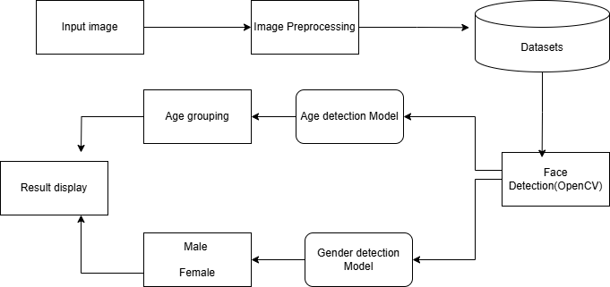

Figure 1:Block diagram of CNN model

1. Input Image
The system starts by taking an image as input, typically containing one or more human faces. This image acts as the primary raw data for the pipeline. It could come from a file, a real-time camera feed, or be part of a dataset. The system’s accuracy heavily depends on the quality and clarity of the input image since it will directly influence the ability to detect facial features and patterns.

2. Preprocessing
Once the input image is received, preprocessing operations are performed. These include resizing the image to a fixed resolution, normalizing pixel intensity values by subtracting the mean RGB values, and converting the image into a format compatible with the deep learning models used later. This standardization ensures consistency, reduces noise, and improves model performance.

3. Dataset
After preprocessing, the image data is referenced or compared against a pre-trained dataset. This dataset has been used to train the underlying models for both face detection and classification. It includes thousands of annotated face images labeled with age and gender categories. The dataset serves as the knowledge base that the models rely on when making predictions about new, unseen images.

4. Face Detection Model
The next stage involves applying a face detection algorithm to the preprocessed input. This model scans the image for facial patterns and returns coordinates for any detected faces. These bounding boxes help identify which regions of the image correspond to human faces and isolate them for further processing, while ignoring the rest of the background.

5. Age and Gender Classification Model
Each detected face is passed through two different but structurally similar deep neural networks — one for gender classification and another for age estimation. These models are typically convolutional neural networks trained on the dataset mentioned earlier. They take the face regions as input and output probabilities corresponding to various gender and age categories, from which the most likely prediction is selected.

6. Output Generation and Display
The final stage combines the predictions and overlays them on the original image. A rectangle is drawn around each detected face, and a label showing the predicted gender and age range is placed near it. This annotated image is then displayed in a window, providing a visual confirmation of the system’s results. Users can verify the predictions in real-time or on saved images.

MODEL CONFIGURATION

This section describes the technical specifications and configuration details of the models used for predicting age and gender. The configuration encompasses the model types, input formats, output labels, and the computational framework utilized.

The success of any AI-based image classification system lies in the choice and configuration of the underlying models. In this age and gender prediction system, we use pre-trained Convolutional Neural Networks (CNNs). These models were trained using the Caffe deep learning framework on large facial datasets, which enables them to generalize well on unseen images. This section explores the configuration of these models in detail — including architecture components, model files, preprocessing techniques, output structure, and usage rationale.

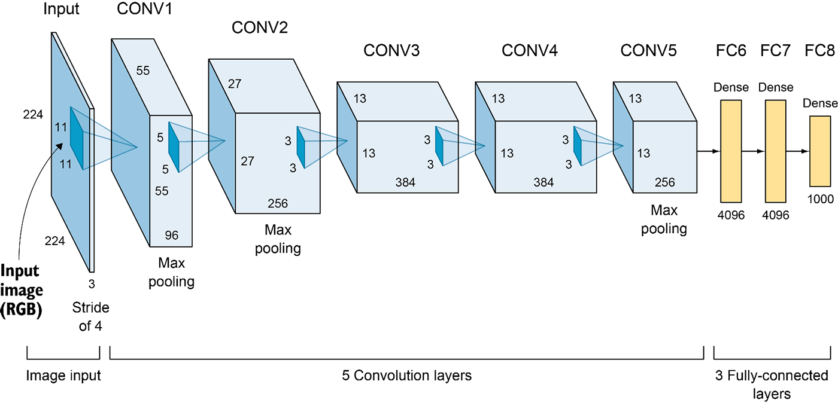

Figure 2: Convolutional NN model

The models are trained in Caffe, a deep learning framework known for its speed and efficiency in deploying CNNs. For usage in Python, the models are loaded using OpenCV’s DNN module, which supports Caffe .caffemodel (binary weights) and .prototxt (network architecture) files.
- Gender Detection Files:
  - gender_deploy.prototxt: Defines the model architecture.
  - gender_net.caffemodel: Contains the learned weights of the network.
- Age Detection Files:
  - age_deploy.prototxt: Network architecture definition.
  - age_net.caffemodel: Weights file trained on labeled age data.
These models are loaded using:

gender_model = cv2.dnn.readNetFromCaffe('gender_deploy.prototxt', 'gender_net.caffemodel')
age_model = cv2.dnn.readNetFromCaffe('age_deploy.prototxt', 'age_net.caffemodel')

Both models are CNN-based and follow a typical layered structure designed for image classification tasks. They consist of:

- Convolutional layers: Extract spatial features such as eyes, nose, wrinkles, or hair patterns.
- ReLU activation layers: Introduce non-linearity and help learn complex patterns.
- Pooling layers: Reduce spatial dimensions to make the model more efficient.
- Fully connected layers: Perform final reasoning to decide the output class.
- Softmax layer: Converts raw output scores into probabilities for each class.
Though the exact layer count can differ, these models generally follow the AlexNet-like structure — a proven architecture for image recognition tasks.

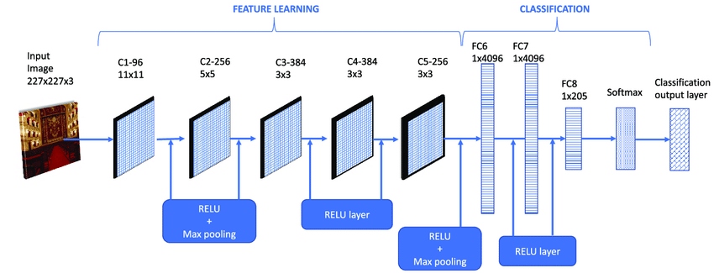

Figure 3: Pre trained caffe model CNN
The model used in this project is built using a Convolutional Neural Network (CNN) architecture. This type of architecture is well-suited for image-based tasks, as it can effectively extract spatial and visual patterns from pixel data. The CNN model processes input facial images through several stages to determine age and gender with high accuracy. Below is a breakdown of the core components of this architecture:
The convolutional layers are the foundational building blocks that extract low-level to high-level features from the input image. These layers use filters (kernels) that slide over the image and learn to detect various spatial patterns, such as edges, textures, and important facial structures like eyes, eyebrows, nose contours, wrinkles, or hair patterns. Early layers typically learn to detect simpler patterns, while deeper layers focus on more complex features.
Following each convolutional layer is a ReLU (Rectified Linear Unit) activation layer. These layers introduce non-linearity into the network, which is essential for learning complex patterns and relationships within the data. Without non-linear activation, the network would behave like a simple linear model and fail to capture the intricate details that distinguish different faces or age characteristics.
Next, the pooling layers (often max pooling) are used to downsample the feature maps. These layers reduce the spatial dimensions (height and width) while preserving the most important information. This not only helps in reducing the computational load but also makes the model more robust to small translations or variations in the input image, such as changes in lighting or slight rotations.
As the data passes through successive convolution, activation, and pooling layers, it eventually reaches one or more fully connected layers. These dense layers act as the decision-making part of the network. They take all the high-level features extracted from earlier layers and use them to classify the input. For gender prediction, this typically results in a binary classification (male/female), while for age prediction, it maps to a range of predefined age groups.
Finally, the output from the last fully connected layer is passed through a Softmax layer, which converts the raw output values (logits) into probabilities. This allows the network to predict the most likely age group or gender by assigning a confidence score to each possible class. The class with the highest probability is selected as the final output.
Though the exact number and configuration of layers may vary, the general structure resembles an AlexNet-like architecture, a deep CNN known for its effectiveness in image classification tasks. This structure provides a balanced trade-off between performance and computational efficiency, making it suitable for real-time applications like this one.

Framework and Tools

The models are developed and trained using the Caffe deep learning framework and are utilized within Python using the OpenCV’s DNN module. OpenCV provides an abstraction to work with Caffe models without requiring the native Caffe installation, thus simplifying deployment.

  - Gender Prediction Model

- Model File: gender_net.caffemodel
- Configuration File: gender_deploy.prototxt
- Input Format: 227x227 pixel RGB image blob
- Preprocessing: Mean subtraction with standard RGB values

- Classes:
  - Class 0: Male
  - Class 1: Female

- Architecture:
This model consists of several convolutional layers followed by pooling, ReLU activations, and fully connected layers. It outputs a 2-class softmax result representing the likelihood of the face being male or female.

  - Age Prediction Model

- Model File: age_net.caffemodel
- Configuration File: age_deploy.prototxt
- Input Format: Same as the gender model (227x227 RGB blob)
- Age Classifications:
The model outputs one of the following eight predefined age ranges:
  - (0–2)
  - (4–6)
  - (8–12)
  - (15–20)
  - (25–32)
  - (38–43)
  - (48–53)
  - (60–100)

- Architecture:
Similar to the gender model, this CNN uses multiple convolutional layers with activation functions followed by fully connected layers. The final layer produces an 8-class probability distribution, from which the class with the highest probability is selected as the predicted age group.

  - Input Preprocessing Parameters

To ensure consistency with how the models were trained, input images must be preprocessed in a specific way. This step is critical, as improper preprocessing can lead to significantly reduced accuracy.
- Image resizing: Each detected face is resized to (227, 227) pixels.
- Channel order: The model expects BGR format (OpenCV default), not RGB.
- Mean subtraction: The average pixel values used during training are subtracted from the input:

MODEL_MEAN_VALUES = (104.0, 117.0, 123.0)

These values represent the global mean of the training dataset (ImageNet/Caffe).
- Blob conversion: Converts the image into a 4D blob to match the model’s expected input shape:

blob = cv2.dnn.blobFromImage(image, 1.0, (227, 227), MODEL_MEAN_VALUES, swapRB=False)

Before feeding any image into the CNN models, it is converted into a blob using OpenCV's cv2.dnn.blobFromImage() function with the following configuration:

blob = cv2.dnn.blobFromImage(image, 1.0, (227, 227),
(104, 117, 123), swapRB=False)
- 1.0 – Scale factor
- (227, 227) – Target size of the image
- (104, 117, 123) – Mean values for each channel (BGR format)
- swapRB=False – Channel order (default BGR)

SOFTWARE INTEGRATION

  - Importing Required Libraries

Figure 4: code part 1

The cv2 library is part of OpenCV, which is an open-source computer vision library widely used for real-time image and video processing. By importing cv2, you gain access to numerous image processing functions like loading images, resizing them, applying transformations, and running deep learning models (such as the pre-trained models in this code).

  - Loading and Preprocessing the Image



Figure 5: code part 2

The first line cv2.imread() loads an image from the disk and stores it as a NumPy array. This is the base step for any image processing task, as it brings the image into memory where it can be manipulated. The path to the image file is specified, and in this case, it's '/Users/faizrehman/project/female_1.jpeg'. This path needs to be correct for the image to load successfully.
The second line resizes the image to 720 pixels in width and 640 pixels in height using cv2.resize(). Resizing images is a common step in computer vision because models often expect a fixed-size input. By standardizing the size, you ensure that the face detection and prediction models work efficiently. Additionally, resizing helps reduce the computation time, as smaller images are processed faster.

3. Defining Model Files

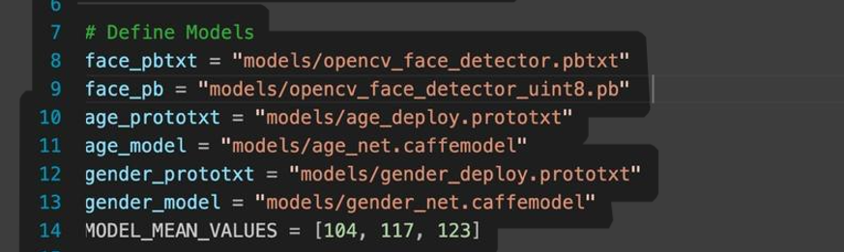
Figure 6: code part 3

In this section, you define the paths to several pre-trained models and configuration files. These models are used for specific tasks like face detection, age prediction, and gender prediction. The models used here are pre-trained deep learning models based on the Caffe framework.
- face_pb and face_pbtxt: These are the model and configuration files for face detection. OpenCV uses these files to detect faces in images.
- age_model and age_prototxt: These files are used to load the pre-trained model and its configuration for predicting a person's age based on the detected face.
- gender_model and gender_prototxt: Similar to the age prediction, these files are used for predicting gender from the face.
MODEL_MEAN_VALUES is a list of values used for image preprocessing. It is common in deep learning to normalize images before they are input into a model. The mean values adjust the color channels (Blue, Green, Red) to match the values the model was trained on.

4. Loading the Pretrained Models

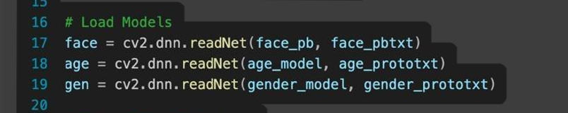
Figure 7:code part 4

In this section, we use the cv2.dnn.readNet() function to load the pre-trained models into memory. This function loads both the model weights and the configuration file that defines how the model should process input data.
- face_net loads the face detection model, which will be used to identify faces in the image.
- age_net loads the age prediction model.
- gender_net loads the gender prediction model.
Once the models are loaded into memory, they can be used for inference. The cv2.dnn.readNet() function initializes a deep learning network that you can use to run predictions on images.

5. Setting Up Classifications

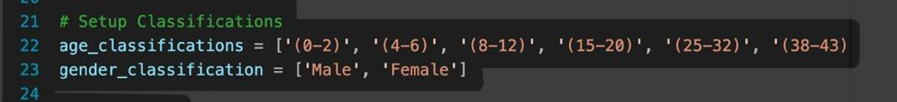
Figure 8: code part 5

Here, two lists are defined:
- age_classifications contains the possible age ranges the age detection model can predict. The model is trained to output one of these ranges based on the face it detects.
- gender_classifications defines the two possible gender outputs: 'Male' and 'Female'. These labels are used to interpret the output of the gender detection model.
These classification lists will help interpret the numerical output from the models into human-readable categories.

6. Copying the Image and Extracting Image Dimensions

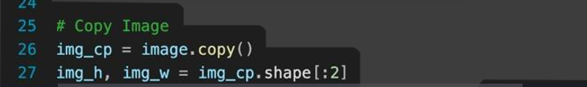
Figure 9: code part 6
In this section, you create a copy of the input image (img_cp = image.copy()). This is important because you might modify the image (e.g., drawing bounding boxes) during the processing. By creating a copy, you preserve the original image.
img_h, img_w = img_cp.shape[:2] extracts the height and width of the image (img_h and img_w). These dimensions are needed when drawing the bounding boxes around detected faces. The shape[:2] returns the height and width of the image, and we will use these values to scale the coordinates of the detected faces.

7. Creating Blob and Detecting Faces

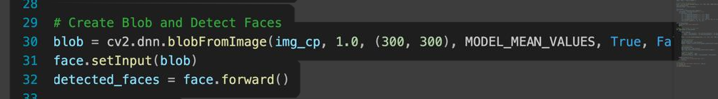
Figure 10: code part 7
- This section creates a blob from the input image using the function cv2.dnn.blobFromImage(). A blob is a preprocessed image that is suitable for input into a deep learning model.
  - The parameters passed to cv2.dnn.blobFromImage() include:
    - The input image (img_cp).
    - 1.0: Scaling factor, which resizes the image.
    - (300, 300): The target size to which the image is resized before being passed to the model.
    - MODEL_MEAN_VALUES: These are subtracted from the image to normalize it before prediction.
    - True: Indicates that the model expects the image in the BGR color format.
    - False: Indicates the model doesn't require swap channels (as the default OpenCV image is in BGR format).
After converting the image into a blob, face_net.setInput(blob) sets the blob as the input to the face detection model. face_net.forward() then performs the forward pass, running the model and obtaining the detected faces' locations.

8. Looping Through Detected Faces and Drawing Bounding Boxes

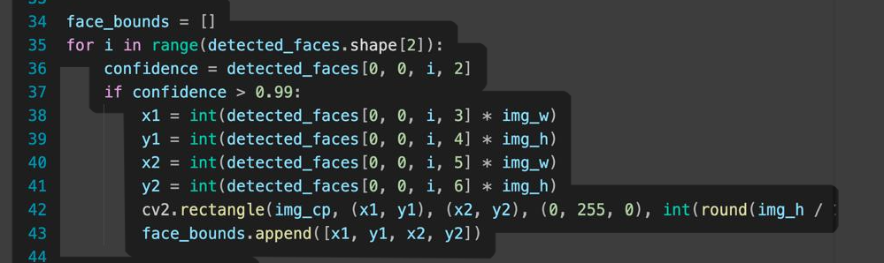
Figure 11: code part 8

After the faces are detected, the code iterates over all detected faces. detected_faces.shape[2] gives the number of detected faces. For each detected face, the confidence score (confidence = detected_faces[0, 0, i, 2]) is extracted, and only faces with a confidence score greater than 0.99 are considered valid.
The bounding box coordinates for each face are calculated using the face detection model's outputs. These are stored as x1, y1, x2, and y2. These coordinates are then scaled according to the image dimensions (img_w and img_h) to fit the detected bounding box within the image. A green rectangle is drawn around each face using cv2.rectangle().
The coordinates of the bounding box are stored in face_bounds to be used later for age and gender predictions.

9. Handling No Faces Detected


Figure 12: code part 9

If no faces are detected (face_bounds is empty), the code prints a message indicating that no faces were detected, and then it exits the program using exit(). This is an essential check to avoid errors later in the code when trying to process non-existing faces.

10. Detecting Age and Gender for Each Face

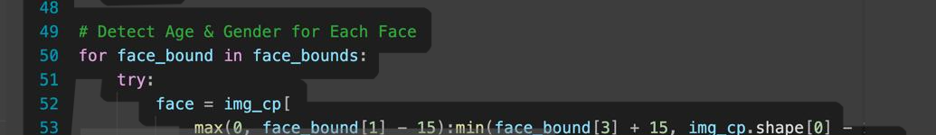
Figure 13: code part 10

For each face detected in face_bounds, the code extracts the face region using the coordinates of the bounding box and adds a buffer around the face for better prediction accuracy. This cropped face image is passed through a pre-trained model for gender and age classification.

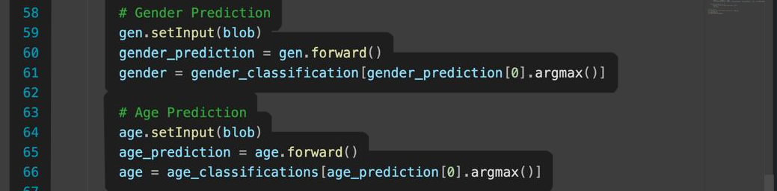
Figure 14: code part 11
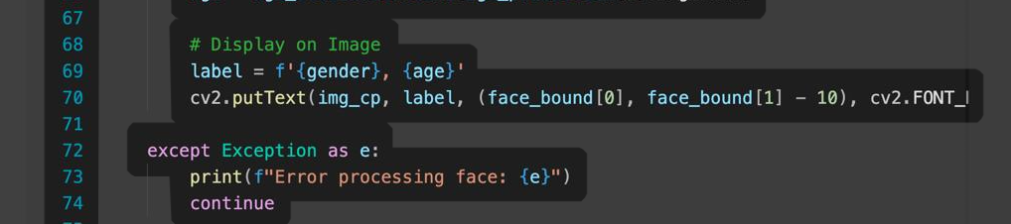
Figure 15:code part 12
• Gender Prediction: The face is passed through the gender model using gender_net.setInput(blob) and gender_net.forward(). The output of the model is a vector, and the argmax() function returns the index of the highest value, which corresponds to the predicted gender.
• Age Prediction: Similarly, the age is predicted using the age_net model. The predicted age group is then displayed on the image using cv2.putText().

11. Final Image Display and Saving

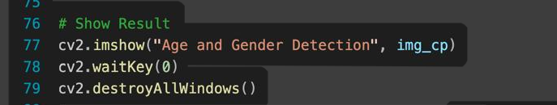
Figure 16: code part 13

Finally, the processed image with bounding boxes and age/gender predictions is displayed using cv2.imshow(). The cv2.waitKey(0) function waits for a key press to close the window. After that, cv2.destroyAllWindows() is called to close all OpenCV windows.

WORKING
The system for age and gender detection involves several distinct, yet interrelated steps, each leveraging a specialized deep learning model to provide highly accurate predictions based on input images. The process is designed to be modular, allowing for easy updates, scalability, and real-time application. The system operates through a clear pipeline: model initialization, image input and preprocessing, face detection, demographic classification (age and gender), and finally, output display and annotation.

1. Model Initialization
Before any image can be processed, the system must load the pre-trained deep learning models necessary for recognizing faces, and subsequently, classifying their age and gender. The model loading is done using OpenCV’s Deep Neural Network (DNN) module, which is designed to read models in various formats (e.g., Caffe, TensorFlow, Torch, etc.). In this case:
- The face detection model is typically loaded as a Caffe-based deep learning network, which is specifically trained to detect human faces in images. It is loaded using the function cv2.dnn.readNetFromCaffe() or cv2.dnn.readNet().
- The age and gender prediction models are both CNN-based (Convolutional Neural Networks) and are trained to classify faces into age categories (e.g., 0-2 years, 25-32 years, 38-43 years, etc.) and gender (male or female). These models are loaded into memory similarly through the cv2.dnn.readNet() function.
The models are designed to take an image input, process it, and output the required predictions (i.e., bounding box coordinates for face detection and labels for age and gender).

2. Input Image Processing and Blob Creation
Once the models are initialized, the next step involves processing the input image to prepare it for inference by the models. Blob creation is the process by which an image is converted into a suitable format that can be fed into deep learning models.
- The image is first resized to a consistent size (e.g., 720x640 pixels). This resizing ensures that the image fits the models' expected input dimensions and scales the image to the correct aspect ratio.
- The image is then normalized to prepare it for the model. The normalization process involves subtracting the model’s predefined mean values and adjusting the pixel values to a standard range, usually [0, 1]. This step is important to ensure that the model sees the image in the same way it saw the images during training.
- The image is then converted into a 4D blob using OpenCV's cv2.dnn.blobFromImage() function. A blob is a multi-dimensional array that stores the image's pixel values in a specific format that the model can process. This blob is then passed into the model for face detection.
This pre-processing ensures that the system has consistent input, allowing the model to operate optimally regardless of variations in the input image's size or color composition.

3. Face Detection
The next key task in the system is face detection, which uses the pre-trained face detection model to locate any faces in the image. Once the blob is created and passed to the model, the model processes the image and detects regions of interest (ROIs) that contain faces.
- The face detection model produces an output that includes a confidence score for each detected face and the bounding box coordinates (x1, y1, x2, y2) representing the location of the face within the image. The confidence score is a measure of how certain the model is that the detected object is indeed a face.
- The system uses a confidence threshold (usually set at 0.99) to filter out faces that have a low probability of being actual faces. This ensures that only the most reliable face detections are retained.
- The bounding box coordinates are then scaled relative to the original image's dimensions, allowing the system to accurately locate the face in any given image. Once the faces are located, they are cropped out of the image, resulting in individual face regions that can be further processed for age and gender prediction.
If no faces are detected, the system alerts the user, ensuring that only relevant data is processed.

4. Demographic Classification (Age and Gender)
With the faces detected and isolated, the next task is to predict the age and gender of the individual in the detected face. This is achieved by passing each face region through the age classification model and the gender classification model, respectively.
4.1 Age Classification
- The cropped face region is resized to 227x227 pixels, as expected by the age model.
- The resized image is converted into a blob, which is then passed to the age model for inference.
- The age model outputs a probability distribution across predefined age categories, each representing a specific age range (e.g., 0-2 years, 4-6 years, 25-32 years, etc.).
- The system then selects the age group with the highest probability and assigns that as the predicted age of the individual in the image. This classification helps the system categorize the detected individual into one of the predefined age groups based on their facial features.
4.2 Gender Classification
- Similarly, the face region is passed through the gender model, where it is resized to the appropriate input size (e.g., 227x227 pixels).
- The output from the gender model is a probability that the detected face belongs to either a male or a female.
- Based on this probability, the system assigns a gender label (either "Male" or "Female") to the detected face.

5. Image Annotation and Output Display
Once the age and gender have been predicted, the final step is to annotate the image with the results and display it to the user.
- A bounding box is drawn around each detected face, with the coordinates obtained during the face detection phase. This visually highlights the location of the face within the image.
- The predicted age and gender labels are then overlaid above the bounding box. This is done using OpenCV’s cv2.putText() function, which allows the system to place the text annotations in a specific location on the image.
- The image, now annotated with both the bounding boxes and demographic labels, is displayed in a new window using OpenCV’s cv2.imshow() function.
- The system then waits for the user to press a key to close the window, allowing the user to view the annotated results. The system can be further extended to work in real-time, processing images from a webcam or a video feed and displaying the results instantly.

6. Error Handling
Throughout the process, there are several points at which errors can occur. For example, face detection might fail in low-light conditions, or the models might not correctly classify the age or gender due to unusual facial features. In such cases, the system includes error handling mechanisms that ensure the program continues running smoothly.
- If no faces are detected, the system prints an error message indicating the lack of face data, preventing unnecessary further processing.
- During age and gender prediction, if the models fail to process a face (due to unusual conditions, such as occlusions or poor image quality), the system catches these errors using try-except blocks and prints the respective error messages for troubleshooting.
The working of the Age and Gender Detection System integrates multiple deep learning techniques for real-time face detection and demographic classification. By leveraging pre-trained CNN models for age and gender classification, along with the robust face detection capabilities of OpenCV, the system is capable of efficiently and accurately predicting age and gender from images. Each component of the pipeline – from image preprocessing to annotation – works together seamlessly to deliver a usable and scalable solution for various real-time applications, such as surveillance, security, and interactive media.
This modular approach allows for easy integration of additional models or features in the future, such as emotion recognition or facial expression analysis, further enhancing the capabilities of the system.

FLOWCHART

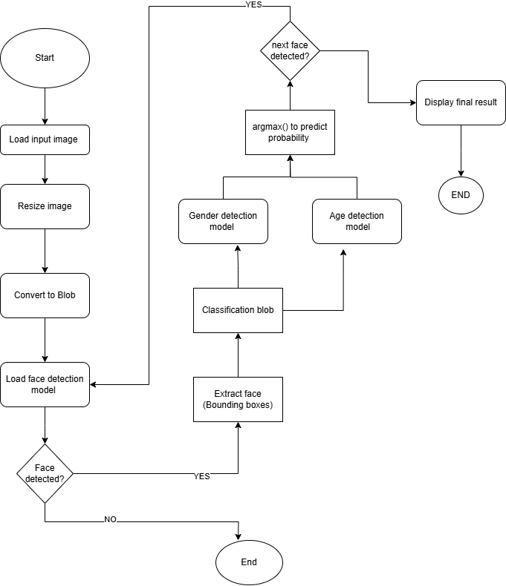
Figure 17: flowchart of implementation

1. Input Image Acquisition:

The process starts with capturing or loading an input image. This can be done either through a webcam feed or by loading a static image file from a storage location. The image is read into the system for further processing.

2. Image Preprocessing:

Once the image is loaded, it undergoes preprocessing. This step involves resizing the image to a fixed size, normalizing the pixel values (subtracting mean values), and converting the image into a blob format. The blob format is required to make it compatible with the deep learning models.

3. Face Detection:

After preprocessing, the face detection model (typically a deep learning model like OpenCV's DNN module) is applied to the image. The model detects faces in the image and provides coordinates (bounding boxes) for each face. These coordinates are used to crop the faces from the image for further analysis.

4. Face Cropping:

Using the bounding box coordinates obtained from the face detection model, each face is cropped out from the original image. This is done to isolate each face and reduce the computational load for subsequent predictions.

5. Blob Conversion for Gender and Age Models:

After cropping the faces, the next step is to convert the face regions into blobs. These blobs are processed by both the gender and age classification models. A blob is a pre-processed
representation of the image that the deep learning models can process for predictions.

6. Gender Prediction:

The cropped face blobs are passed into a gender prediction model (typically a CNN model trained on gender classification). The model outputs the predicted gender (male or female) based on the facial features.

7. Age Prediction:

Simultaneously, the same face blob is passed into an age prediction model. The age model provides an estimated age group for the face, such as 0-2, 4-6, 15-20, 25-32, etc. The model uses the features of the face, such as wrinkles, skin texture, and other physical characteristics, to make this prediction.

8. Display Results:

Once both predictions (age and gender) are made, the results are overlaid on the original image. The predicted age and gender labels are displayed near the detected face(s) using text annotations, and bounding boxes are drawn around each face to highlight the detections.

9. Final Output:

The final image, with the overlaid results, is displayed to the user. This is typically shown in a GUI window or saved as an output image file. The program waits for the user to press a key, after which it ends the process and releases all resources.

TESTING AND RESULT

The testing phase of the Age and Gender Detection system was carried out to evaluate its accuracy, reliability, and performance under real-world conditions. The primary goal was to verify that the system could successfully detect faces, predict age ranges, and classify gender in various types of images, including those with varying lighting conditions and facial orientations.

Test Setup and Process:

To begin with, a wide range of images featuring individuals of different ages, genders, and ethnicities were selected for testing. These images included portraits, group photos, and images with faces at different angles. The system was tested in the following steps:

- Face Detection:
The first step involved detecting faces in each image. The OpenCV DNN-based face detection model was used to locate the position of faces within the image. The face detection process was performed using a blob extracted from the image, which was then passed through the pre-trained face detection model. The system successfully identified faces in most cases, even in scenarios where the faces were partially obscured or tilted at an angle.

- Age and Gender Classification:
After detecting the faces, the next step was to predict both the age range and gender. The pre-trained models for age and gender classification were used to predict the age and gender based on the detected face. The system used a classification approach where it selected the age range (such as 0-2, 4-6, 8-12, 15-20, 25-32, 38-43) and gender (Male/Female) for each detected face.

- Displaying Results:
Once the predictions were made, the system overlaid the predicted age and gender labels on the original image, allowing for a visual confirmation of the system's performance. The labels were displayed at the top of the detected face, clearly indicating the predicted age range and gender.

Evaluation Criteria:

The results were evaluated based on the following criteria:

- Accuracy of Age Prediction: The age range prediction was considered accurate if the system correctly predicted the person’s age within the defined ranges. For instance, if the person was 30 years old, the system should ideally predict the 25-32 age range.

- Accuracy of Gender Prediction: Gender classification was evaluated by comparing the predicted gender (Male/Female) with the actual gender of the person in the image.

- Face Detection Accuracy: This was assessed based on whether the system successfully detected all faces in an image, even in crowded settings or when the faces were at different angles.

Testing Results:

- Face Detection Performance:
The system demonstrated strong performance in detecting faces, even in less-than-ideal conditions. In test images with multiple faces or occluded faces, the system successfully detected the faces and marked their locations with bounding boxes. However, in some challenging scenarios, such as when the face was tilted or partially obstructed, the detection rate decreased slightly.

- Age Prediction Accuracy:
The age prediction model performed reasonably well in classifying the age ranges. For the majority of images, the system predicted the correct age range within a reasonable margin of error. However, the model occasionally misclassified individuals with atypical facial features or those with ambiguous age characteristics. For example, a person with a young-looking face but an older age may have been predicted as being in the wrong age bracket.

In some cases, the system predicted individuals in the age group adjacent to their actual age range. For example, a 22-year-old was sometimes classified in the 25-32 range rather than 15-20. This was more common in cases where the individual appeared more mature than their age.

- Gender Prediction Accuracy:
The gender classification was highly accurate, with most individuals being classified correctly as either male or female. The system made correct predictions for a large number of images, even those with mixed-gender groups. However, in some cases with androgynous faces or images where lighting made the features less discernible, there were minor prediction errors. These cases were rare, but they highlighted the limitations of the gender classification model.

- Performance Under Different Conditions:
The system’s performance was generally consistent across images with different lighting conditions, such as bright sunlight or dimly lit rooms. The model was able to detect faces and make accurate predictions in these varied settings, although the performance in low light or with heavy shadows did decrease slightly. Additionally, the system worked effectively on images where faces were turned slightly away from the camera, but as the angle of the face increased, the accuracy of both age and gender prediction declined.

Sample Results:

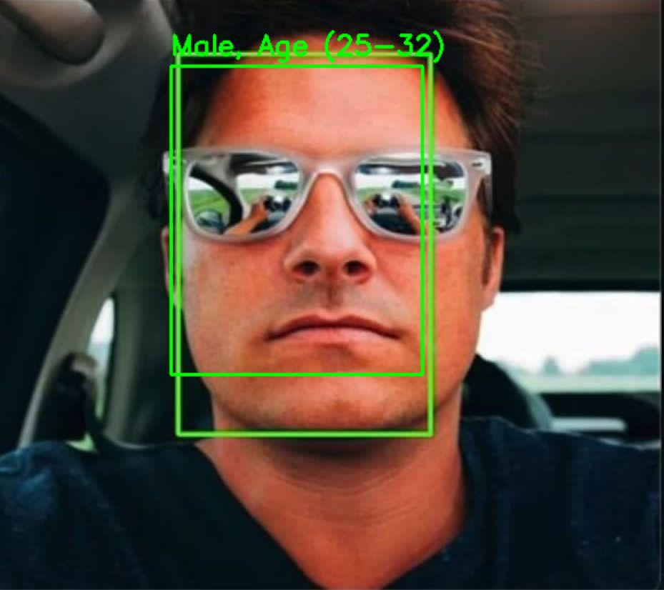
Figure 18: test1

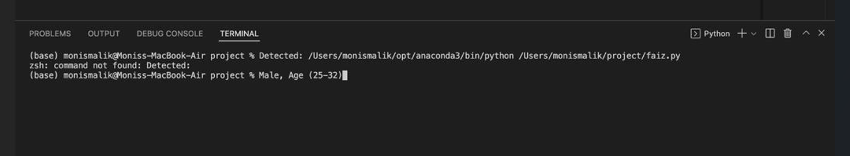
Figure 19: terminal result 1
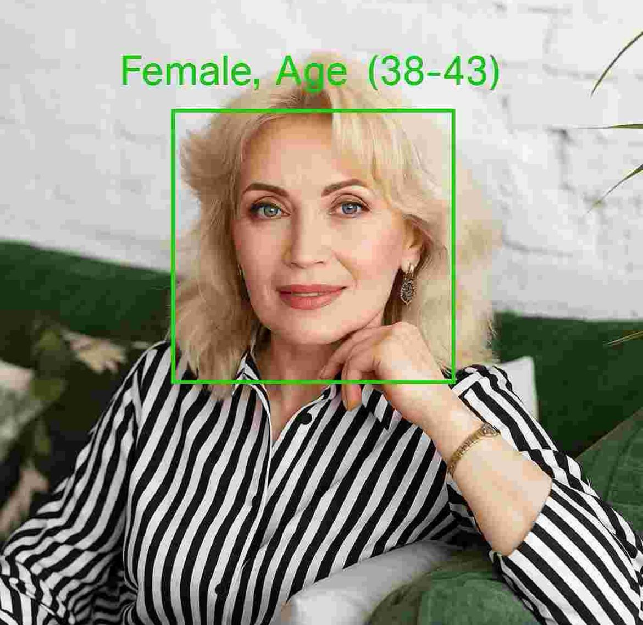
Figure 20: test 2

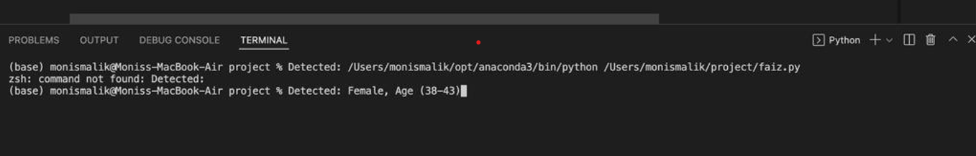
Figure 21: terminal result 2

Conclusions from Testing:
The system successfully met its design objectives by detecting faces and predicting age and gender with a high degree of accuracy. While the system performed well in most cases, there were instances where the accuracy was affected by factors such as face angle, lighting conditions, and facial appearance. However, these issues are common in facial recognition tasks and can be mitigated with further model refinement.
The gender prediction was particularly robust, with very few errors observed. Age classification, on the other hand, showed some variation, especially in cases where the person appeared younger or older than their biological age.
The results demonstrate the effectiveness of using pre-trained models for age and gender classification, and the system has shown potential for practical applications in areas such as demographic analysis, age-based content filtering, and personalized user interactions.

CONCLUSION AND FUTURE SCOPE

This project developed an advanced age and gender detection system using deep learning-based facial recognition. By utilizing pre-trained models for both age and gender classification, the system was able to identify and classify human faces into predefined age groups and gender categories. The workflow consists of a series of steps including face detection, image preprocessing, and feeding the detected face region into the respective deep learning models for age and gender prediction.
The system employs powerful computer vision techniques via OpenCV and deep neural networks for reliable face detection and classification. The OpenCV-based framework helps in detecting faces with high accuracy, and the pre-trained age and gender models based on the Caffe framework classify the detected faces into predefined categories. The result is then overlaid on the image, providing both real-time feedback and a visualization of the identified age group and gender.
The performance of the system has been evaluated under controlled conditions using a range of test images. The detection accuracy of the system is robust for standard datasets, such as the UTKFace dataset, ensuring good prediction for a variety of human faces. By processing the image, detecting faces, and predicting the demographic features, the system is capable of making reliable demographic inferences based solely on facial images.
In terms of system integration, this approach combines face detection with age and gender classification, providing a streamlined solution suitable for applications such as surveillance, user interaction, and demographic profiling. While the current implementation focuses on static images, the model's accuracy can be adapted for real-time processing, enhancing the utility of the system in practical applications.
This project demonstrates the practical use of deep learning and computer vision techniques to solve complex real-world problems. The ease of integration with existing systems and the potential for scalable applications in various industries makes it an excellent proof-of-concept for demographic analysis through facial recognition technology.

Future Scope

Despite the solid performance of the age and gender detection system, there are several avenues for further enhancement and expansion. The following points outline potential areas for improvement and future development:

- Improved Model Accuracy via Transfer Learning:
While the pre-trained models used in the project provided good results, the system can be improved by fine-tuning the models with a larger and more diverse dataset. Transfer learning, where the model is first trained on a larger general dataset and then fine-tuned on a specialized one, can help improve the accuracy of predictions, especially for faces that are underrepresented in the training dataset.

- Emotion and Expression Recognition:
The addition of emotion and facial expression recognition could significantly enrich the system's capabilities. This would enable the system to recognize not only demographic features (age and gender) but also emotional states (e.g., happy, sad, angry). This functionality could be used in applications where emotional engagement is important, such as customer service, mental health diagnostics, and interactive entertainment.

- Real-Time Video Processing:
The current system works on static images. However, a more powerful application would involve processing live video feeds. Real-time age and gender classification in video streams would open up new use cases, such as monitoring demographics in public spaces, enhancing security systems, and tailoring advertisements based on the demographic of the person currently viewing a screen. Integration with streaming platforms and mobile devices could make this system even more applicable in real-world scenarios.

- Multi-Face Detection and Tracking:
While the current system can detect and process a single face at a time, it can be expanded to handle multiple faces simultaneously. This feature would be useful in scenarios such as crowded areas, events, or gatherings where multiple people are in view. Implementing facial tracking along with multiple-face detection would allow the system to continuously follow faces through video streams, making it possible to analyze demographics in dynamic environments.

- Cross-Cultural and Cross-Age Validation:
The pre-trained models are primarily designed to work with certain demographic groups based on the dataset they were trained on. Expanding the dataset to include faces from a broader spectrum of ethnic backgrounds and age ranges would increase the model's accuracy in real-world scenarios. Additionally, testing the system across various cultural and ethnic backgrounds would make the system more universally applicable and reduce the biases inherent in datasets.

- Privacy and Ethical Considerations:
The implementation of facial recognition technology raises privacy concerns, particularly in regard to surveillance applications. Future development should focus on ensuring the system adheres to privacy standards and regulations such as GDPR (General Data Protection Regulation). Moreover, ethical considerations should guide the use of this technology to prevent misuse, such as unauthorized surveillance, profiling, or invasion of privacy. Incorporating user consent protocols and ensuring data anonymization will be vital in building trust in this technology.

- Integration with Other Recognition Systems:

The age and gender recognition system could be further enhanced by integrating with other forms of biometric recognition, such as voice recognition, gait analysis, and even emotion analysis through voice or text. Multi-modal systems, where several types of biometric data are analyzed simultaneously, could provide a more accurate and holistic profile of individuals, suitable for applications in security, personalized services, and healthcare.

- Edge Computing for Faster Processing:

Deploying the system on edge devices such as smartphones, security cameras, or IoT devices would allow for faster processing and reduced dependency on cloud computing. Optimizing the models to run efficiently on edge devices, with a focus on low-power consumption and real-time analysis, would make the system more accessible in environments with limited computing resources. This also ensures quicker inference times, especially in real-time applications.

- Personalized Marketing and Advertising:
One of the most significant applications of demographic recognition is in marketing and advertising. The system can be integrated into digital signage, smart TVs, or advertising boards to deliver personalized ads based on the age and gender of the viewer. Additionally, it could be employed in e-commerce platforms, providing product recommendations and targeted ads that are more likely to resonate with the user's demographic profile, leading to higher conversion rates and user satisfaction.

- Healthcare Applications:

In the healthcare domain, age and gender detection can be used to tailor medical services, assessments, or health recommendations. For example, automated healthcare kiosks could use this system to adjust the content shown to patients based on their demographic information. In telemedicine, the system could assist healthcare professionals in understanding patient profiles better, potentially improving diagnosis and personalized treatment planning.

- Ethics and Accountability in AI:
As the technology advances, it is crucial to create ethical frameworks that ensure transparency, accountability, and fairness in AI-based decision-making processes. In facial recognition systems, where biases might emerge due to underrepresentation in training datasets, it is important to build solutions that are not discriminatory. Developers must implement safeguards against algorithmic bias and ensure that AI models are continually monitored for fairness across different demographic groups.

By addressing these future areas, this age and gender detection system can evolve into a more sophisticated, versatile, and ethical tool for various industries and applications. As machine learning techniques improve and computational resources become more affordable, the potential applications for such systems will continue to expand, offering significant societal and commercial benefits.

REFERENCES
[1] M. Gupta, R. P. Yadav, and R. Yadav, "Age, Gender and Emotion Prediction Using Deep Learning," Proceedings of the 2023 International Conference on AI and Deep Learning, New Delhi, India, 2023

[2] H. H. S., S. C. K., S. S. K., S. S. Gowda, and S. S. V., "Age Gender and Emotion Identification Using Face Recognition," International Research Journal of Modernization in Engineering, Technology and Science, vol. 3, no. 7, July 2021.

[3] M. Saraswat, "Age Gender and Emotion Estimation Using Deep Learning," in Congress on Intelligent Systems, Proceedings of CIS 2021, Volume 2, Jul. 2022, pp. 59–70.

[4] D. B. Khadse, G. H. Atilkar, I. S. Ukey, P. C. Mankar, "Age, Gender and Emotion Detection Using Deep Learning," JETIR Journal of Engineering, Technology, and Innovation Research, vol. 10, no. 4, April 2023.

[5] H. Yin, S. Wang, and X. Liu, "Multi-task Learning for Emotion Recognition from Facial Expressions," IEEE Transactions on Affective Computing, vol. 11, no. 2, pp. 430-442, Apr. 2020.

[6] K. He, X. Zhang, S. Ren, and J. Sun, "Delving Deep into Rectifiers: Surpassing Human-Level Performance on ImageNet Classification," in Proceedings of the IEEE International Conference on Computer Vision (ICCV), 2015, pp. 1026-1034.

BIBILOGRAPHY

- OpenCV Foundation. (n.d.). OpenCV - Open Source Computer Vision Library. Retrieved from https://opencv.org/

- Yangqing Jia, Evan Shelhamer, et al. (2014). Caffe: Convolutional Architecture for Fast Feature Embedding. Retrieved from https://caffe.berkeleyvision.org/

- Rajalingappaa Shanmugamani. (2018). Deep Learning for Computer Vision. Packt Publishing. ISBN: 978-1788621755.

- PyImageSearch. (2020). Real-Time Face Detection with OpenCV. Retrieved from https://pyimagesearch.com

- Chia-Cheng Liu, Siwei Lyu, and Yuan Li. (2015). Age and Gender Prediction using Deep Learning. IEEE Transactions on Image Processing. DOI: 10.1109/TIP.2015.2463195.

- Y. LeCun, Y. Bengio, and G. Hinton. (2015). Deep Learning. Nature. 521(7553):436-444. DOI: 10.1038/nature14539.

- Adrian Rosebrock. (2020). OpenCV and Python for Real-Time Computer Vision. PyImageSearch. Retrieved from https://pyimagesearch.com

- X. Zhang, Z. Zhang, and Y. Song. (2017). UTKFace Dataset: A Large-Scale Dataset for Age, Gender, and Ethnicity Prediction. Retrieved from https://susanqq.github.io/UTKFace/

